Your name here
Client name (if applicable):
Your name here
Your Name:
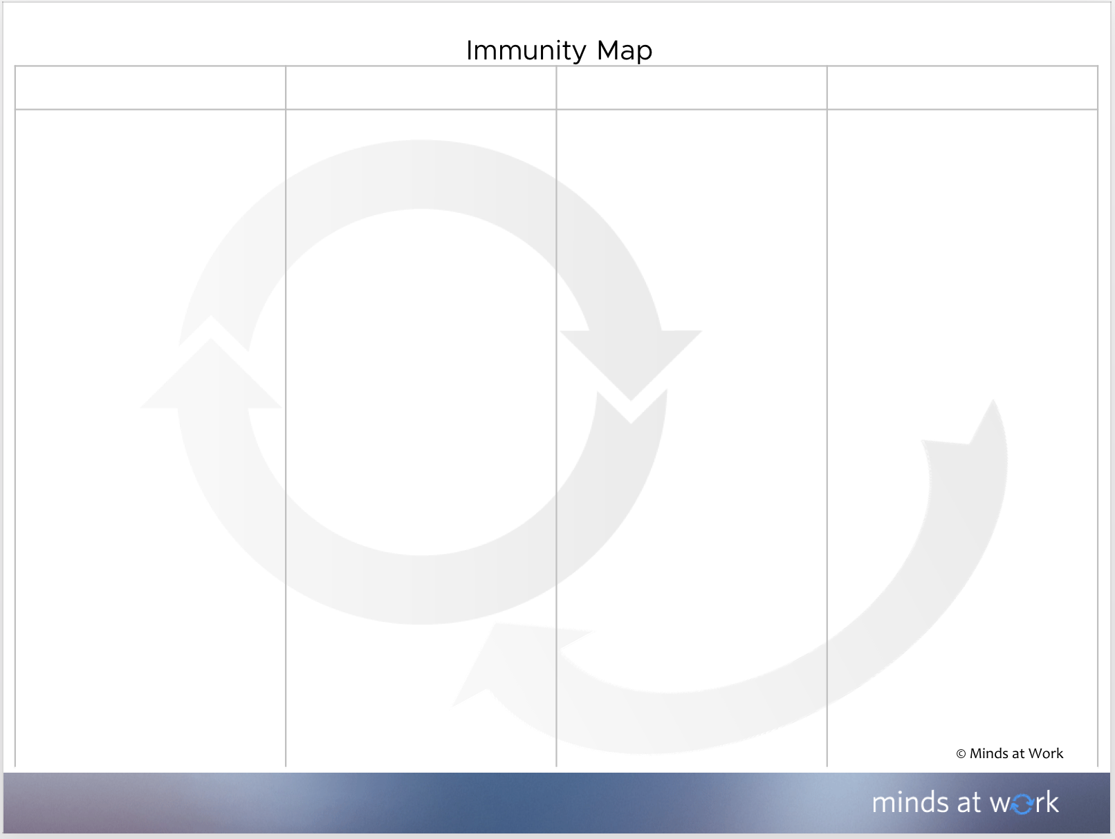
If you are applying to be a qualified ITC Map Facilitator, don’t forget to include your commentary on page 2.

2. DOING? NOT DOING (vs #1)
1. COMMITMENTS
(Improvement Goal)
4. BIG ASSUMPTIONS

3. HIDDEN COMMITMENTS

Worry Box

Write in here…
Write in here…
Write in here…
Write in here…
Write in here…

For each map, please include a few sentences of commentary on this page addressing at least one of the following:
- where – specifically -- you think it is strong
- where you think it might need to be tightened up
- how the Big Assumptions explain the Immune System
- how you think you might dig deeper into Column 4 of the Map.

